|  |  |  |  |
| --- | --- | --- | --- |
| **Branch: Instrumentation & Control Engineering** | | **Year:** Second Year | |
| **Division: C** | **Roll No: 04** | **GR Number: 11911180** | **Subject:** OOPS |
| **Assignment No: 7** | **Date of Submission: 29-05-2021** | **Student Full Name: Shaunak Sudhir Deshpande** | |

Aim: Implement C++/Java/Python program to create a base class called shape. Use this class to store two double type values that could be used to compute the area of figures.

Derive two specific classes called function get_data() to initialize base class data members and another member function display_area() to compute and display the area of figures.

Make classes to suit their requirements. Using these three classes, design a program that will accept dimension of a triangle or a rectangle interactively, and display the area.

Remember the two values given as input will be treated as lengths of two sides in the case of rectangles, and as base and height in the case of triangles, and used as follows:

Area of rectangle= x*y Area of triangle =1/2*x*y

Software Used: JDK, VSCode

Code:

import java.util.Scanner;

class Shape{

    double x,y;

    void get_data() {

        Scanner S= new Scanner(System.in);

        System.out.print("Enter base and height: ");

        x=S.nextDouble();

        y= S.nextDouble();

        S.close();

    }

}

class Triangle extends Shape{

    void display_area() {

        double area;

        area=0.5*x*y;

        System.out.println("Area = "+area);

    }

}

class Rectangle extends Shape{

    void display_area() {

        double area;

        area=x*y;

        System.out.println("Area = "+area);

    }

}

public class Area {

    public static void main(String args[]) {

        int choice;

        while(true){

        System.out.println("\tMENU"+"\n1. Triangle"+"\n2.Rectangle"+"\n3. Exit");

        System.out.println("Enter your choice:");

        Scanner S=new Scanner(System.in);

        choice=S.nextInt();

        switch(choice){

        case 1:Triangle tri=new Triangle();

        tri.get_data();

        tri.display_area();

        break;

        case 2: Rectangle rect = new Rectangle();

        rect.get_data();

        rect.display_area();

        break;

        case 3: S.close();

        System.exit(0);

        default: System.out.println("Invalid Choice Entered");

}

        }

    }

}

Output:

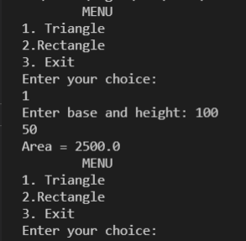

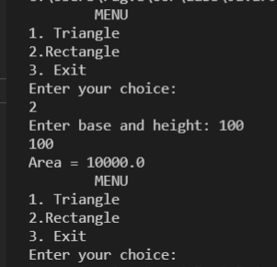

Analysis of Program:

In this program, we are trying to find the area of a triangle and a rectangle. Since these are both shapes, we are creating a parent class called Shape. Then we use inheritance in order to create a relationship between these three classes and implement the Area class, which holds the main() function, and calls these classes for calculation.

Conclusion:

This code is an example of using inheritance in Java. We use Multiple inheritance to show the relationship between different shapes. Here, Shape is the parent (base) class and Triangle and Rectangle are the child (sub) classes.